**2 States : The story of my marriage**

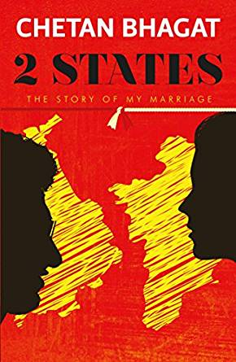



**Final Conclusion** : 2 States is the real marriage story of the author written in simple language and a must read book for bollywood masala story lovers !

Overall Ratings : 3.5 / 5